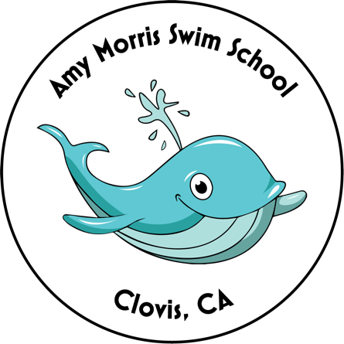
Swim Lesson Application

Contact Person / Parent
Last Name_________________________________
First Name_________________________________
Phone#____________________________________
E-Mail_____________________________________
Mailing Address
Street_____________________________________
City_______________ZIP_____________________

Child#1_______________________________ Child#2_____________________________
Age________________Sex M/F___________ Age_______________Sex M/F__________
Birthday_____/_______/_________________ Birthday______/________/____________
Had lessons previously? Y/N____________ Had lessons previously? Y/N_________
Where / When? ________________________ Where / When? ______________________
Circle One: Circle One:
Non-Swimmer Beginner Swimmer Non-Swimmer Beginner Swimmer
Intermediate Swimmer Baby & Me Intermediate Swimmer Baby & Me

Circle preferred start month for lessons: May June July August

List below the dates and times you are/are not available for lessons (ex: am only, eve only, June only, M/W, T/TH) Please remember family vacations and appointments. Be as flexible and clear as possible. *Please add any other helpful information on the back of this application form. * We are open 9am-6:30pm M-TH. NO Friday lessons!
_________________________________________________________________________________________________________________________________________________________________________________________________________________________________________________________________________________________________________________________________________________________________________________________________________________________________________

Please mail this form along with your $100 deposit PER CHILD:
Amy Morris 1757 Jordan Avenue Clovis, CA 93611
- Make checks payable to: Amy Morris Swim School
- Remaining balance due in full to confirm all lessons.
- After we receive your form/deposit, we will contact you with current availability and a tentative schedule.

See you at the pool!!
Questions? – Amy Morris (559) 299-8080 OR amymorrisswimschool@outlook.com

